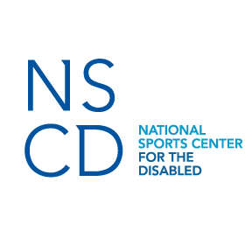
News Release

MEDIA CONTACT:

Maria Miller

(303) 847-1409

maria@kmalcogroup.com

The NSCD’s Hal O’Leary Recipient of the 2015 Mayor’s Diversity Award

Denver, Colo. (Aug. 4, 2015) – The National Sports Center for the Disabled (NSCD) is pleased to announce that Hal O’Leary, founder of the NSCD, will be awarded the 2015 Mayor’s Diversity Award in the Denver Commission for People with Disabilities category. The awards ceremony took place on Oct. 1 at the Holiday Event Center. Ten honorees were recognized as community champions of equality and justice.
Hal founded the NSCD 45 years ago and has been instrumental in teaching those with disabilities find the joy in sports. He has played a critical role in raising funds that has provided millions of dollars in financial support to the NSCD. He has also found ways to provide free equipment and lessons since the inception of the program. His support has allowed the NSCD to grow and help more families find their confidence and renew their spirit through sports.
“For decades, Hal O’Leary has been dedicated to helping others,” said Becky Zimmermann, president and CEO of the NSCD. “The result has been countless smiles on the participants’ faces, which is how Hal and the NSCD measure success. When you meet Hal, you can see the excitement on his face when he begins to talk about the participants and then you realize why the NSCD has been so successful.”
Each year more than 3,000 children and adults with disabilities participate in their programs to learn more about sports and themselves. Last winter the NSCD provided more than 22,000 lessons up in Winter Park alone. With specially trained staff and volunteers, and its own adaptive equipment lab, the NSCD teaches a variety of winter and summer sports and activities to individuals with almost any physical, cognitive, emotional or behavioral diagnosis.
About NSCD
The National Sports Center for the Disabled (NSCD) began in 1970 as a one-time ski lesson for children with amputations for the Children's Hospital of Denver. Today, the NSCD is one of the largest outdoor therapeutic recreation agencies in the world. Each year, thousands of children and adults with disabilities take to the ski slopes, mountain trails and playing fields to learn more about sports and themselves. With specially trained staff and its own adaptive equipment lab, the NSCD teaches a variety of winter and summer sports and activities to individuals with almost any physical, cognitive, emotional, or behavioral diagnosis. For more information about the NSCD visit our website at http://nscd.org or like us on Facebook for updates about our programs and athletes.

# # #

