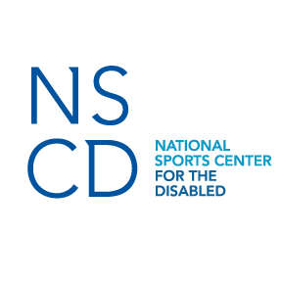
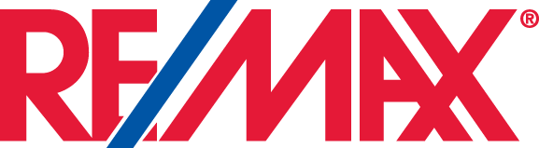
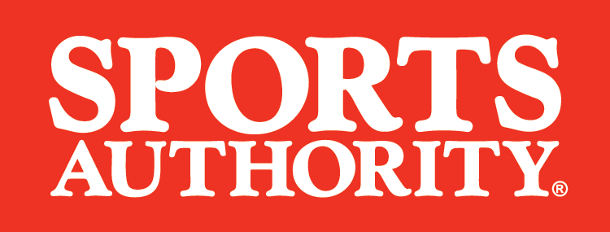
THE NATIONAL SPORTS CENTER FOR THE DISABLED RAISES NEARLY HALF A MILLION DOLLARS AT ANNUAL HAL O’LEARY GOLF CLASSIC

Sports Authority and RE/MAX help NSCD reach record-breaking goal

DENVER, CO – August 13, 2015 – The National Sports Center for the Disabled (NSCD) is pleased to announce that its annual Hal O’Leary Golf Classic raised $472,000 this year. Sports Authority—one of the largest full-line sporting goods retailers in the United States and Puerto Rico—was the title sponsor, and RE/MAX was the presenting sponsor. The event was held at the Sanctuary Golf Course in Sedalia, CO from July 29-30 and brought together nearly 250 men and women of all abilities. All proceeds raised will support NSCD’s programs benefiting the lives of children and adults with any disability.

“We are very grateful for Sports Authority and RE/MAX’s continued support of our organization,” said Becky Zimmermann, president and CEO of the NSCD. “We currently receive only 15 percent of our revenues from participant fees. The remaining 85 percent comes from philanthropic gifts, events and sponsorships—this event is important for our organization which directly benefits our participants.”

The NSCD is recognized around the world as the premier therapeutic recreation organization providing leadership and expertise in adaptive sports. Each year more than 3000 children and adults with disabilities participate in year-round sports and recreational programs through the NSCD. Sports Authority and its vendors donate gear such as camping, water sports and ski and snowboard equipment for these programs, as well as outfit the NSCD staff in durable uniforms.

“This event is a great opportunity to educate more people about the important work the NSCD is doing for people with disabilities,” said Stephen Binkley, EVP and Chief Merchandising Officer of Sports Authority. “The NSCD has helped many people learn more about sports and themselves and we are so proud to be their partner. I’d also like to extend a very special thank you to our vendor community for showing such strong support for this outstanding organization.”

About NSCD
The National Sports Center for the Disabled (NSCD) began in 1970 as a one-time ski lesson for children with amputations for the Children's Hospital of Denver. Today, the NSCD is one of the largest outdoor therapeutic recreation agencies in the world. Each year, thousands of children and adults with disabilities take to the ski slopes, mountain trails and playing fields to learn more about sports—and themselves. With specially trained staff and its own adaptive equipment lab, the NSCD teaches a variety of sports and activities to individuals with almost any physical, cognitive, emotional, or behavioral diagnosis. For more information about the National Sports Center for Disabled visit our website at http://nscd.org or like us on Facebook for updates about our programs and athletes.
About Sports Authority
Headquartered in Englewood, CO, Sports Authority is one of the largest full-line sporting goods retailers, with 462 locations across 41 states and Puerto Rico. Sports Authority offers a broad range of sporting goods from leading brands and is the active family’s destination for footwear, apparel, fitness, team sports and outdoor recreation. The League by Sports Authority, a free and easy rewards program, offers members 5% back after they earn 100 points or more during a quarterly period. For a list of store locations and information, or to shop online, visit sportsauthority.com. Follow Sports Authority on Facebook facebook.com/SportsAuthority and Twitter twitter.com/SportsAuthority.

Media Contact
Maria Miller, KMALCO Group
303-847-1409
Maria@kmalcogroup.com
###

